Entering PD into the KIOSK program

- Enter the KIOSK, sign-in and use the apps drop-down to go to the IPDP link.

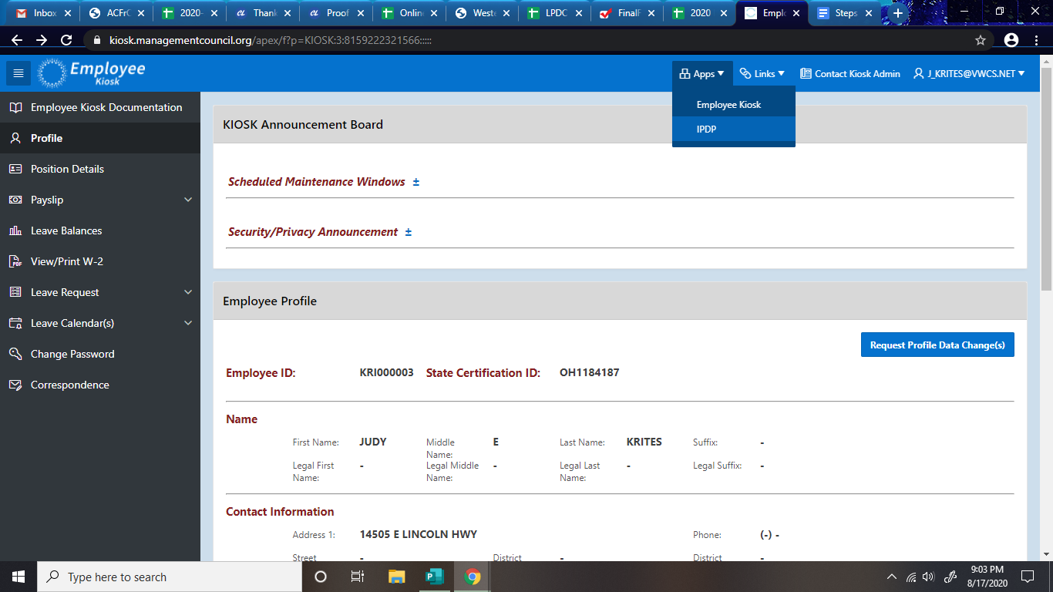

- In the Individual Navigate at the left, choose create activity.

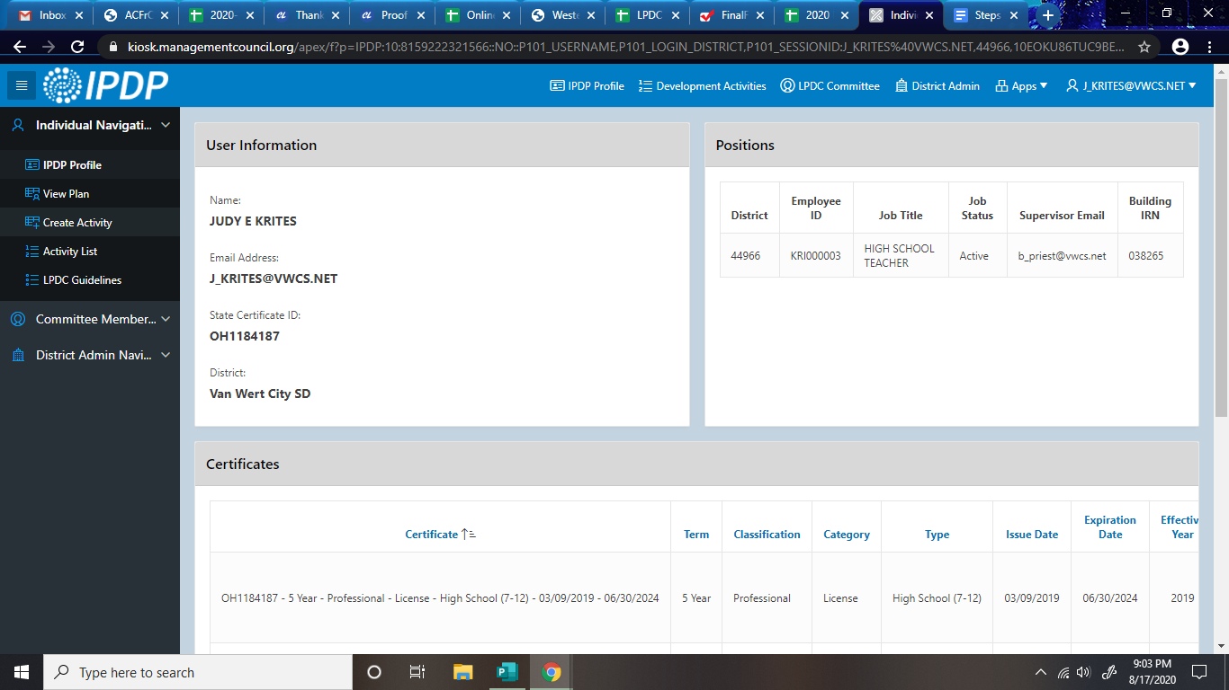

- Fill in accurate information – activity name, correct start and end dates, click only on the license to be renewed (not coaching certificates, etc). Choose appropriate type of verification from drop-down list. Fill in provider (college, PD day, service, etc). Approving supervisor – use default – none.
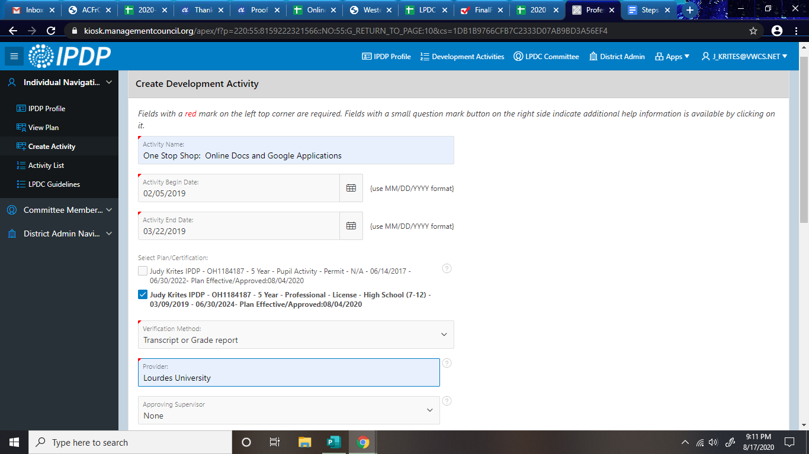

- Input correct number of semester hrs, CEUs (if you know the conversion – 1 hr = .1 CEUs), or contact hrs (just list number of the hours attended). Write a basic description of the PD and complete area of focus or list here the corresponding IPDP goal.

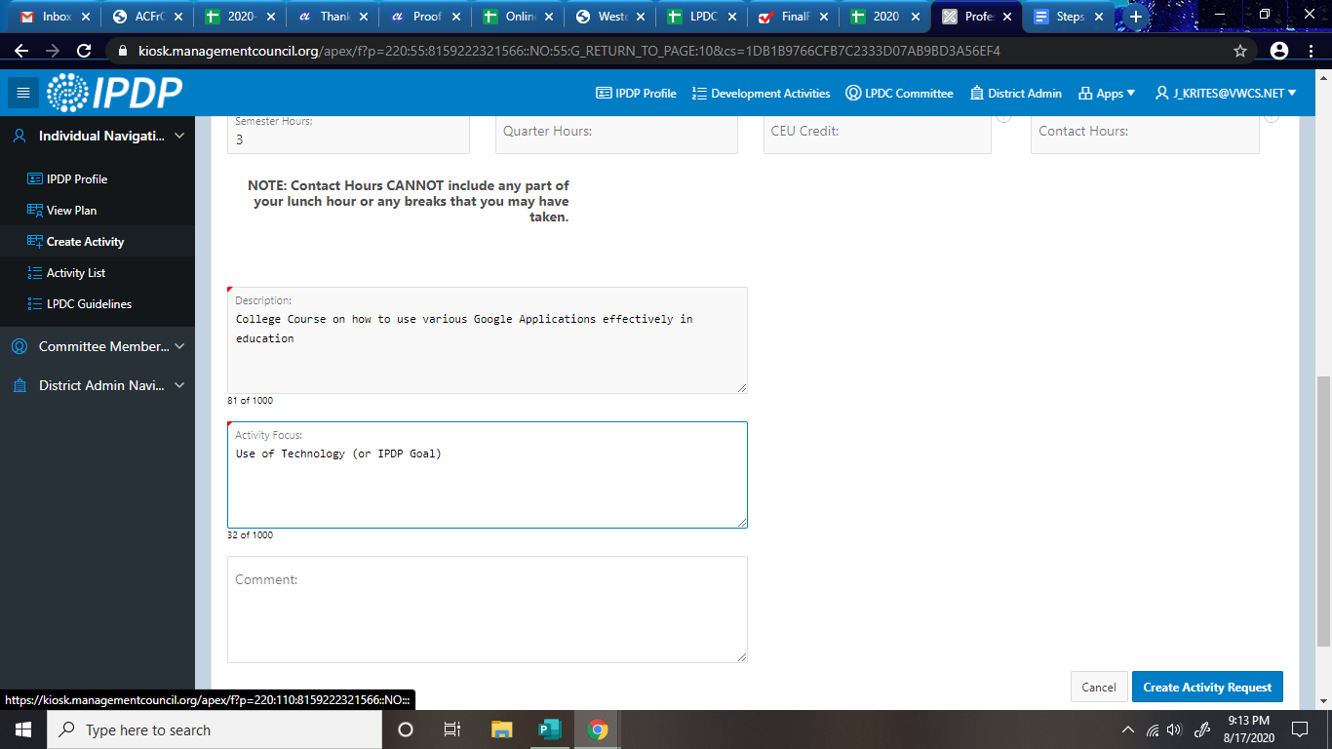
- When complete – click create activity request. Then send corresponding paperwork (nothing for - PD days, literacy collaborative, etc OR PD approval form for any individual PD – college credit, webinars, seminars, conferences, etc.) to Judy Krites.
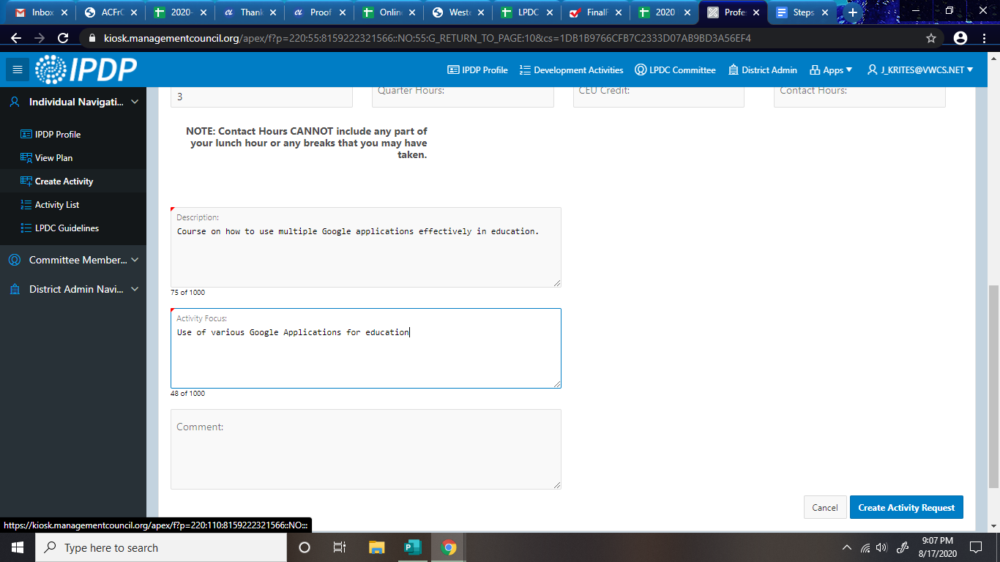

6. Your activity has been now saved but not yet submitted. Complete the following yet:
If you have any paperwork – please scan it and attach it at the bottom of the screen. Paperwork would include transcript, certificate of participation or attendance, journal, time log, PSW transcript, GTIgnite transcript, etc. These should be scanned and saved in your documents.

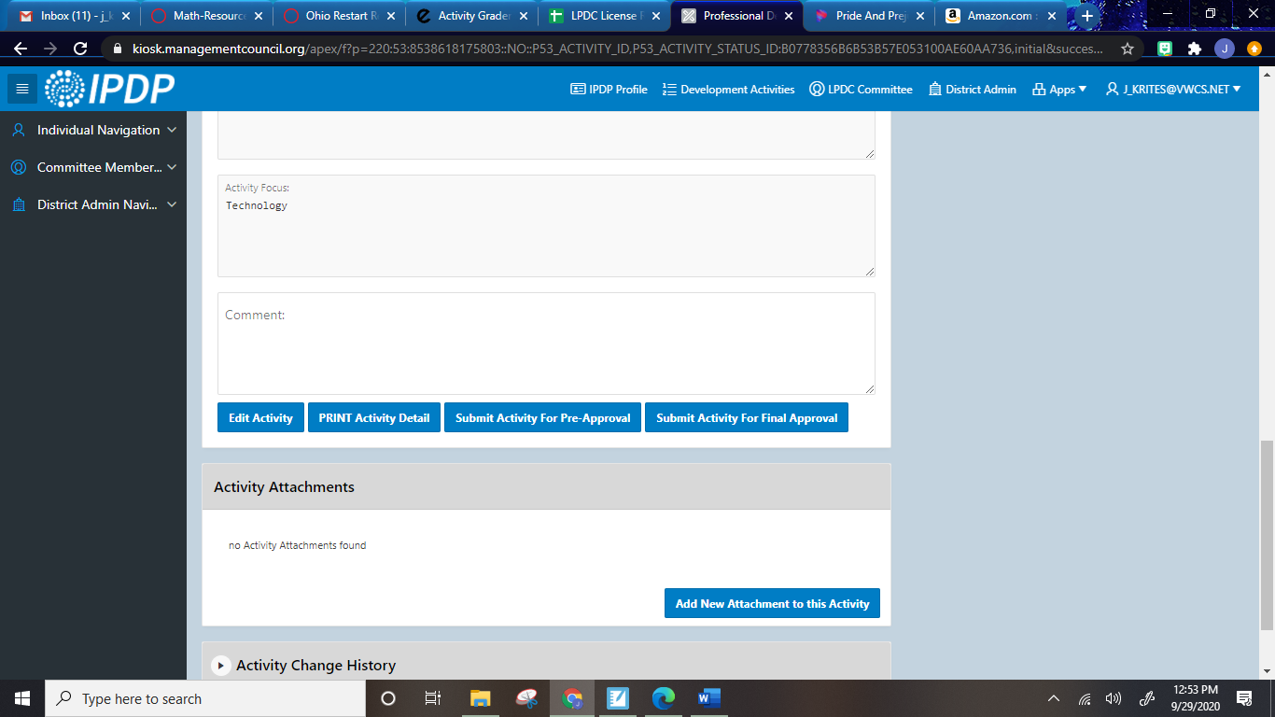
7. Click on submit for final approval.

8. At this point you should get a notification that your PD has been submitted for approval. Patiently wait until the LPDC has read and approved your PD. You will receive an email once approved or denied (with comments as to what do change).

9. All activities/PD will be included in the activity list of the personal IPDP page.

